**clothes shop management system**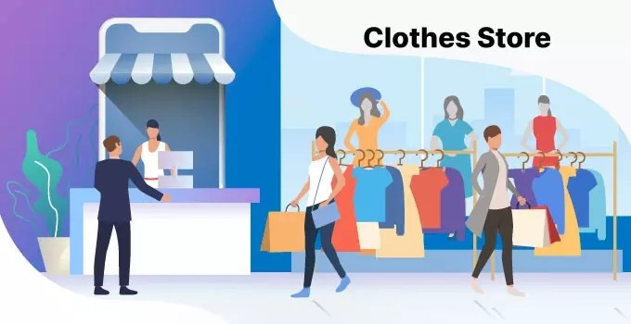

**Team Members: Supervisor**

***1.ادهم اشرف إبراهيم الجنزورى د. شيماء طلعت***

***2. احمد محمد سعيد محمد***

***3. احمد عادل حسن فهيم***

***4.حنان ياسر إبراهيم محمد ربيع***

***5. آيات اشرف محمد اسماعيل***

***6. اية عبد النبي عبد الرؤف***

**Chapter 1**

**Contents:**

Ch1

1.1 Introduction ------------------------------------ 4

1.2 Problem Definition --------------------------- 6

1.3 System Objective ------------------------- 7

1.4 WBS --------------------------------------------- 8

1.5 Project Plan (Gantt Chart) ----------------- 9

1.6 Project risks ----------------------------------- 11

1.7 Safety ------------------------------------------- 12

1.8 Security ----------------------------------------- 15

1.9 **Requirements**----------------------------------17

Ch2

2.1 Use Case Diagram ---------------------------- 20

2.2 Activity Diagram --------------------------------21

2.3 Class Diagram --------------------------------- 23

2.4 Sequence Diagram --------------------------- 24

2.5 Statue Diagram -------------------------------- 26

2.6 Data Flow Diagram --------------------------- 30

Ch3

3.1 GUI

CH1:

***Analysis***

***1.1) Introduction***

***The “Cloth store Management System” was developed to overcome the problems that prevail in the practical manual system. This software is supported to eliminate and, in some cases, reduce the difficulties encountered by this legacy system. Furthermore, this system is designed for the specific business needs to be implemented.***

***Smooth and efficient operation. The application is minimized to avoid data entry errors. It also provides an error message if invalid data is entered. No formal knowledge is required for the use of this system by the user. So all of this proves that it is easy to use. The clothing store management system described above can result in an error free, safe, reliable and fast management system. It can help you focus on other tasks instead of focusing on keeping records. Big or small, every business face challenges and manages information on products, apparel, businesses, payments, and inventory.***

***1.2) Problem Definition:***

***1*) No immediate retrieval of information is possible :- The information is very difficult to retrieve and to find particular information like the stock of a specified cloth, balance, collection, as all the information is stored in the traditional data stores i.e. entry registers and we have to search it manually. This results I inconvenience and wastage of time and may be incorrect information.**

**2) No immediate updation in record is possible: - various changes to the information like employee details i.e. if any employee has changed his address or he got the higher post, his mobile number which are required. If he wants to update the payment details of any employee, stock updating is difficult to do as paperwork is involved.**

**3) Error prone manual calculation: - Manual calculations are error prone and take a lot of time and this may result in incorrect information.**

**For example:**

**calculation of annual balance by the administrator from the bill, payment paid to the employee, manager and subtracting all the expenditure made for maintenance*.***

|  |
| --- |
| ***1.3) System Objective:***   * **To Design and Develop a system as user friendly as**   **Possible.**   * **To Reduces clerical work** * **This not only reduces manual work but also time and**   **And storage Requirements.**   * **To provide the reports related to Employee, Supplier,**   **Cloth Stok etc.…**   * **To improve data accuracy, integrity, consistency, retrieval**   **of information and processing speed.**   * **Make a cloth management system which will take  inputs for the purchase orders and enter them to a**   **Database by validating it.**   * **Keeping the records of transactions like,**    + **Customer’s details.**   + **Customer’s registration.**   + **Number of stock available**   + **Number of orders.**   + **Purchase Details.** * **Unique username & password assigned to admin** * **Admin registration provides security to the system**   **By making the system password protected** |

|  |
| --- |
|  |

***1.4)Work Breakdown Structure(WBS):***

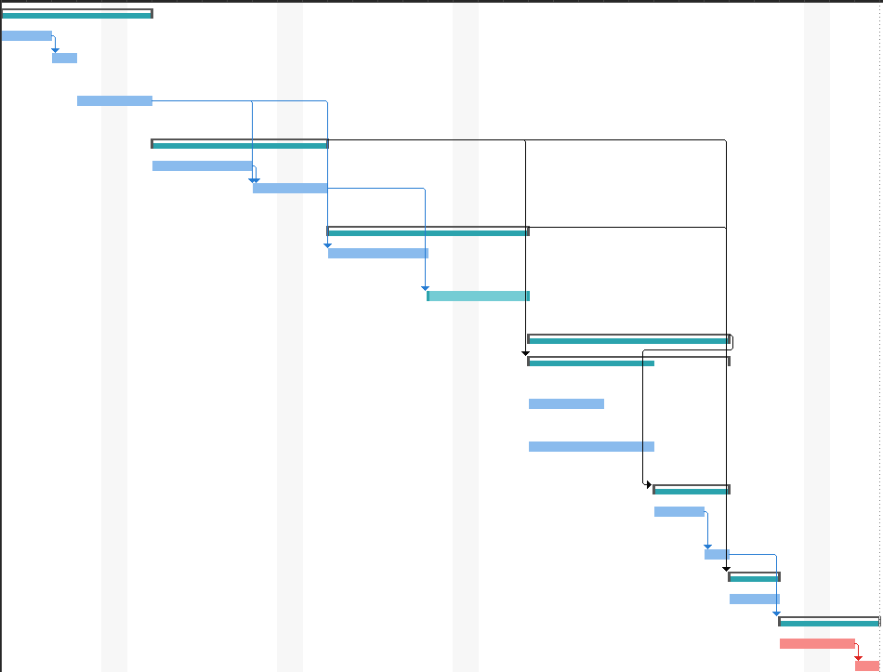

***1.6) Project Risks***

|  |  |  |  |
| --- | --- | --- | --- |
| **Strategy** | **Impact** | **Probability** | **Risk description** |
| Owners must keep an adequate  Supply of clothing on hand. When  Customers enter a store looking for something, they expect the goods to  Available in the color and size of  Their choice. Not purchasing enough  Inventory leads to customer dissatisfaction and lost sales. On the other hand , companies that  Purchase too much inventory may  Incur huge losses by selling excess  Clothing at discounted prices. | **High** | **High** | Inventory Management |
| A business should target the right audience and offer items that are compatible with that audience. In addition, the brand must adapt to changing economic conditions. in times of recession | **High** | **High** | Marketing |
| If one on the team leave working of  The project this will delay the  Delivered time of the project. | **Medium** | **High** | **Team Size** |
| Another risk to the clothing store is trend valuation. Trends in the fashion industry are fickle, ever-changing, and often elusive. The successful store takes advantage of the latest trends and recognizes when those trends are down. One mistake could lead to an overstock. This mistake can be fatal in the clothing industry. Stores may avoid these mistakes by hiring experienced buyers, buying respectable brands, and buying business apparel rather than off-the-shelf, pioneering, dangerous or wasted items. | **High** | **High** | Trend Analysis |

***1.7) Safety Achievements:***

***/ Hazard Avoidance***

**Effective controls protect users from hazards; help avoid hacking; minimize or eliminate safety.**

**To effectively control and prevent hazards, users should:**

**▪ Involve users, who often have the best understanding of the conditions that create hazards and insights into how they can be controlled.**

**▪ Identify and evaluate options for controlling hazards, using a "hierarchy of controls."**

**▪ Use a hazard control plan to guide the selection and implementation of controls and implement controls according to the plan.**

**▪ Develop plans with measures to protect workers during emergencies and nonroutine activities.**

**▪ Evaluate the effectiveness of existing controls to determine whether they continue to provide protection, or whether different controls may be more effective. Review new technologies for their potential to be more protective, more reliable, or less costly.**

***/Hazard Detection and remove***

**The system is designed so that hazards are detected and removed before they result in an accident.**

**Unauthorized Access:**

**if person gains logical or physical access without permission to system or Database or other resource referred to as unauthorized access.**

**System Handle it by checking who access to system and operation happen on the system by making history and system send email message automatically warning the admin that new login detected on the system.**

***/Damage Limitation***

**The system includes protection features that minimize the damage that may result from an accident.**

**Data Loss**

**Data loss is a serious problem for businesses of all sizes — losing files means losing time and money Data loss occurs when data is accidentally deleted, or something causes data to become corrupted Viruses, physical damage or formatting errors can render data unreadable by both humans and software. Losing files and documents in our system we handle that by making copies of data or data files to use in the event the original data or data files are lost or destroyed which called backup of data**

***1.8) Security***

**To achieve Security there are three ways:**

1. **Vulnerability avoidance**
2. **Attack detection and elimination**
3. **Exposure limitation and recovery**

**So, to enhance the security in our clothing system we should take The following steps to prevent breaches in our system:**

**1-Implement monitored alarms:**

Time is critical during a break-in. It only takes criminals a few minutes to burglarize your store. Stay connected to your store by installing monitored alarms. These devices can be installed to detect an open door, broken window or motion. Once triggered, an audible alarm sounds to ward off intruders. At the same time, an alert is sent to your mobile device as well as the monitoring center, which then dispatches the proper authorities.

**2- Integrate Access Control**

Access control technology allows admin to limit who has admittance to areas of your store. By assigning employees unique codes, you’ll know when members of your staff arrive to work and what areas they access at any time. For example, if something is missing from the stock room, time logs can show which employees were in that room and when. This can help you identify the culprit.

**3- Incorporate Electronic Article Surveillance**

Electronic article surveillance is an anti-shoplifting system that involves attaching tags to clothing and merchandise. An employee must remove or deactivate the tag after purchase. If an EAS tag leaves the store without being removed, an alarm sounds and the store owner is alerted immediately.

**4-Install Video Surveillance**

Installing a video surveillance system is one of the most effective ways to enhance security in your store. Not only does a surveillance system provide employees with the evidence needed to prove theft, but just the sight of cameras can work as a deterrent for shoplifters.

**1.9)** **Requirements:**

**Functional Requirements**

Functional requirements define basic actions that the system must execute. The applicable requirements for the system are divided into three main categories: Apparel Inventory, Customer and Billing Information, and Sales and Supplier Information. See use cases for more details.

* Stock of clothing
* The system records the stock of clothing.
* The system needs to be updated when new stock arrives.
* The system records Garments details,
* customer information, and billing
* The system displays customer information.
* The system creates the invoice.
* The system must store customer information.
* The system records the billing Sales and Suppliers
* The system displays and updates supplier information from time to time.

**Non-functional Requirements**  
Non-functional requirements, as the name suggests, are requirements that are not directly concerned with the specific services delivered by the system to its users.  
They may relate to emergent system properties such as reliability, response time, and store occupancy. Alternatively, they may define constraints on the system  
implementation such as the capabilities of I/O devices or the data representations used in interfaces with other systems. non-functional requirements, such as  
performance, security, or availability, usually specify or constrain characteristics of the system.

**Usability:**The system provides a help and support menu in all interfaces for the user to interact with the system. The user can use the system by reading help and support.

**Security:**The system provides username and password to prevent the system from unauthorized access. The staffs’ password must be greater than eight characters. The subsystem should provide a high level of security and  
integrity of the data held by the system, only authorized personnel of the company can gain access to the company’s secured page on the system; and only users with valid password and username can login to view user’s page.

**Performance:**The system response time for every instruction conducted by the user must response quickly.  
The system should have high performance rate when executing the user’s input and should be able to provide a response within a short time.

**Error handling:**Errors should be considerably minimized and an appropriate error message that guides the user to recover from an error should be provided. Validation of user’s input is highly essential.

**Ease of use:**Considering the level of knowledge possessed by the users of this system, a simple but quality user interface should be developed to make it easy to understand and  
require less training

**Chapter 2**

**Use Case Diagram:**

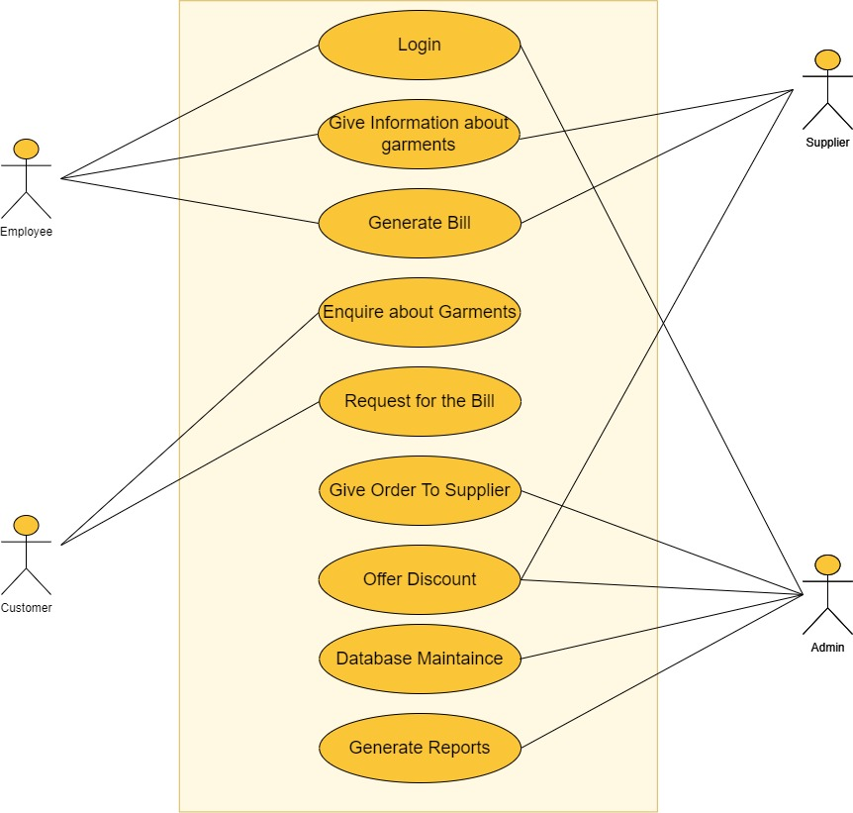

|  |  |
| --- | --- |
| 1 | **Use Case ID** |
| Sign in | **Use Case Name** |
| Student, Administrator | **Actors** |
| 1-The student must do registration | **Pre-conditions** |
| Successfully login | **Past- conditions** |
| 1-Insert the username  2-Insert The password  3-login | **Normal Flows** |
| 1-insert the incorrect username.  2-Insert the incorrect password. | **Alternative Flows** |

|  |  |
| --- | --- |
| 2 | **Use Case ID** |
| Give information about garments. | **Use Case Name** |
| Employee, Supplier. | **Actors** |
| Employee must do login. | **Pre-conditions** |
| View information about garments. | **Past- conditions** |
| 1-Scan correct QR code  2-View information about garments. | **Normal Flows** |
| 1-Scan invalid QR code. | **Alternative Flows** |

|  |  |
| --- | --- |
| 3 | **Use Case ID** |
| Generate bill and give it | **Use Case Name** |
| Employee, supplier | **Actors** |
| 1-employee login into the system | **Pre-conditions** |
| Successfully generate bill | **Past- conditions** |
| 1-Enter customer details  2-calculate total items  3-check discount  4-check way of payment  5-Display total price  6-print bill | **Normal Flows** |
| 1-Insert incorrect name  3-you forgot the password  4-you forgot pin  5-please enter correct pin | **Alternative Flows** |

|  |  |
| --- | --- |
| 4 | **Use Case ID** |
| Enquire about Garments | **Use Case Name** |
| Employee, supplier | **Actors** |
| 1-employee login into the system  2-enquire about the availability of garments | **Pre-conditions** |
| Successfully enquire | **Past- conditions** |
| 1-provide details about garments | **Normal Flows** |
| 1-The Garments are not available | **Alternative Flows** |

|  |  |
| --- | --- |
| 5 | **Use Case ID** |
| Request for the Bill | **Use Case Name** |
| Customer | **Actors** |
| 1-Generate Bill  2-Customer Logged into System | **Pre-conditions** |
| Customer Received Receipt | **Past conditions** |
| 1-Bill Verified  2-Calculate Net Price  3-Determine Payment method  4-Display Payment Successfully  5-Print Receipt | **Normal Flows** |
| 1-Bill Need to be Generate Again  2-Incorrect PIN  3-Error in Calculate Net Price | **Alternative Flows** |

|  |  |
| --- | --- |
| 6 | **Use Case ID** |
| Accept the order | **Use Case Name** |
| supplier | **Actors** |
| 1-Admin login into the system | **Pre-conditions** |
| Successfully print order | **Past- conditions** |
| 1-select supplier  2-place order  3-check supplier accept order  4-reciceved order confirmation  5-make payment for supplier  6-reciceved order  7-print order details | **Normal Flows** |

|  |  |
| --- | --- |
| 7 | **Use Case ID** |
| Offer Discount | **Use Case Name** |
| Supplier, admin | **Actors** |
| Login Successfully | **Pre-conditions** |
| Price Updated Successfully | **Post- conditions** |
| 1-select Garments  2-Make Discount  3-Update Garment Price | **Normal Flows** |
| 1-Not Authorized User  2-Failed to Update Garments price | **Alternative Flows** |

|  |  |
| --- | --- |
| 8 | **Use Case ID** |
| maintenance | **Use Case Name** |
| Administrator | **Actors** |
| Admin Must do Login | **Pre-conditions** |
| Records Updated Successfully | **Post- conditions** |
| 1-add/delete customer  2-update customer Details  3-add/delete Garments  4-update Garments Details  5-Add/Delete Supplier  6-Update Supplier Details | **Normal Flows** |
| 1-Not Authorized User  2-Failed to Update Database | **Alternative Flows** |

|  |  |
| --- | --- |
| 9 | **Use Case ID** |
| Generate Report | **Use Case Name** |
| Admin | **Actors** |
| 1-Generating Report  2-Admin Logged into System | **Pre-conditions** |
| Transaction Success | **Past conditions** |
| 1-Admin Authorized  2-Report Generating  3-Transaction Data View  4-Enter Current Date  5-Display Transaction Based on Date | **Normal Flows** |
| 1-Admin Not Authorized  2-Error in Date  3-Error in Transaction | **Alternative Flows** |

**Activity Diagrams:**

**Inquire About Garments:**

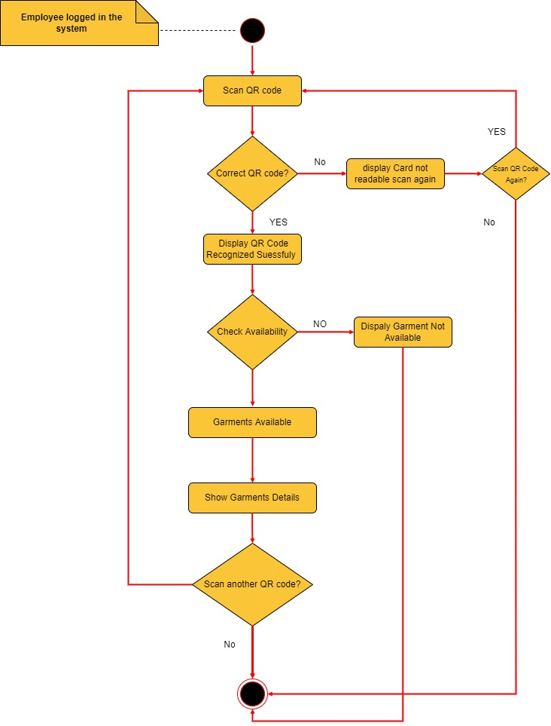

**Generate Bill Details:**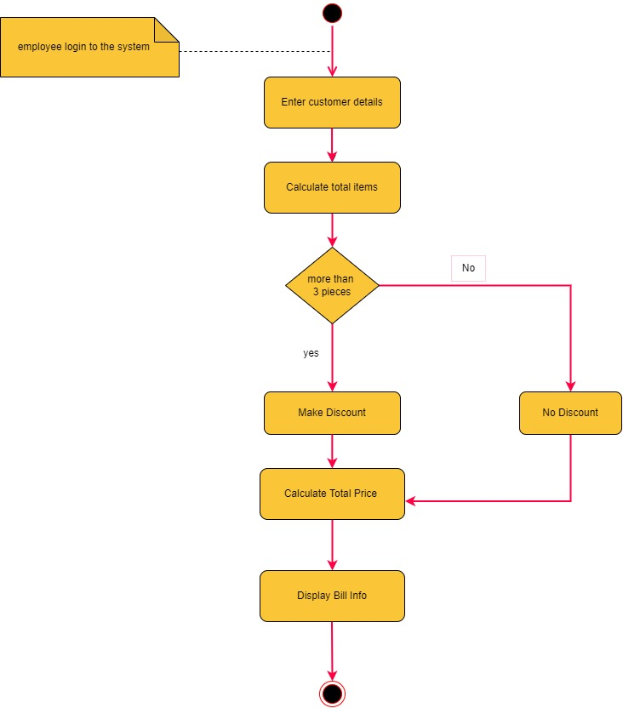

**Request Bill:**

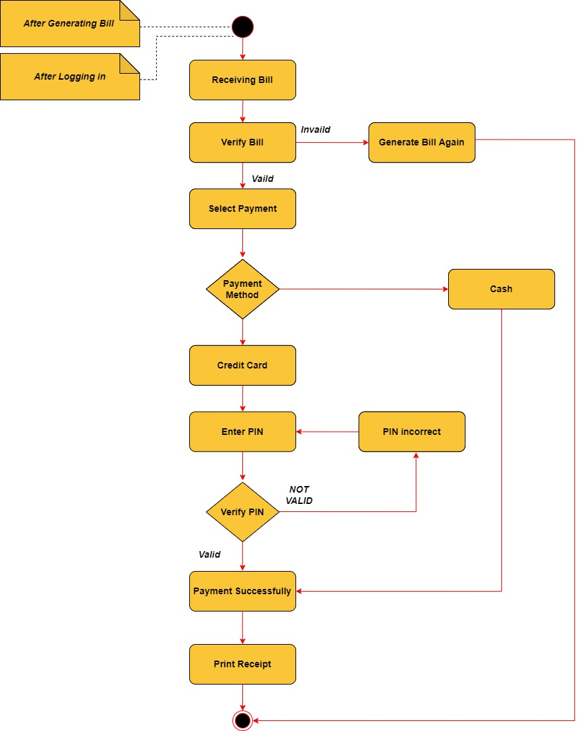

**Database Maintenance:**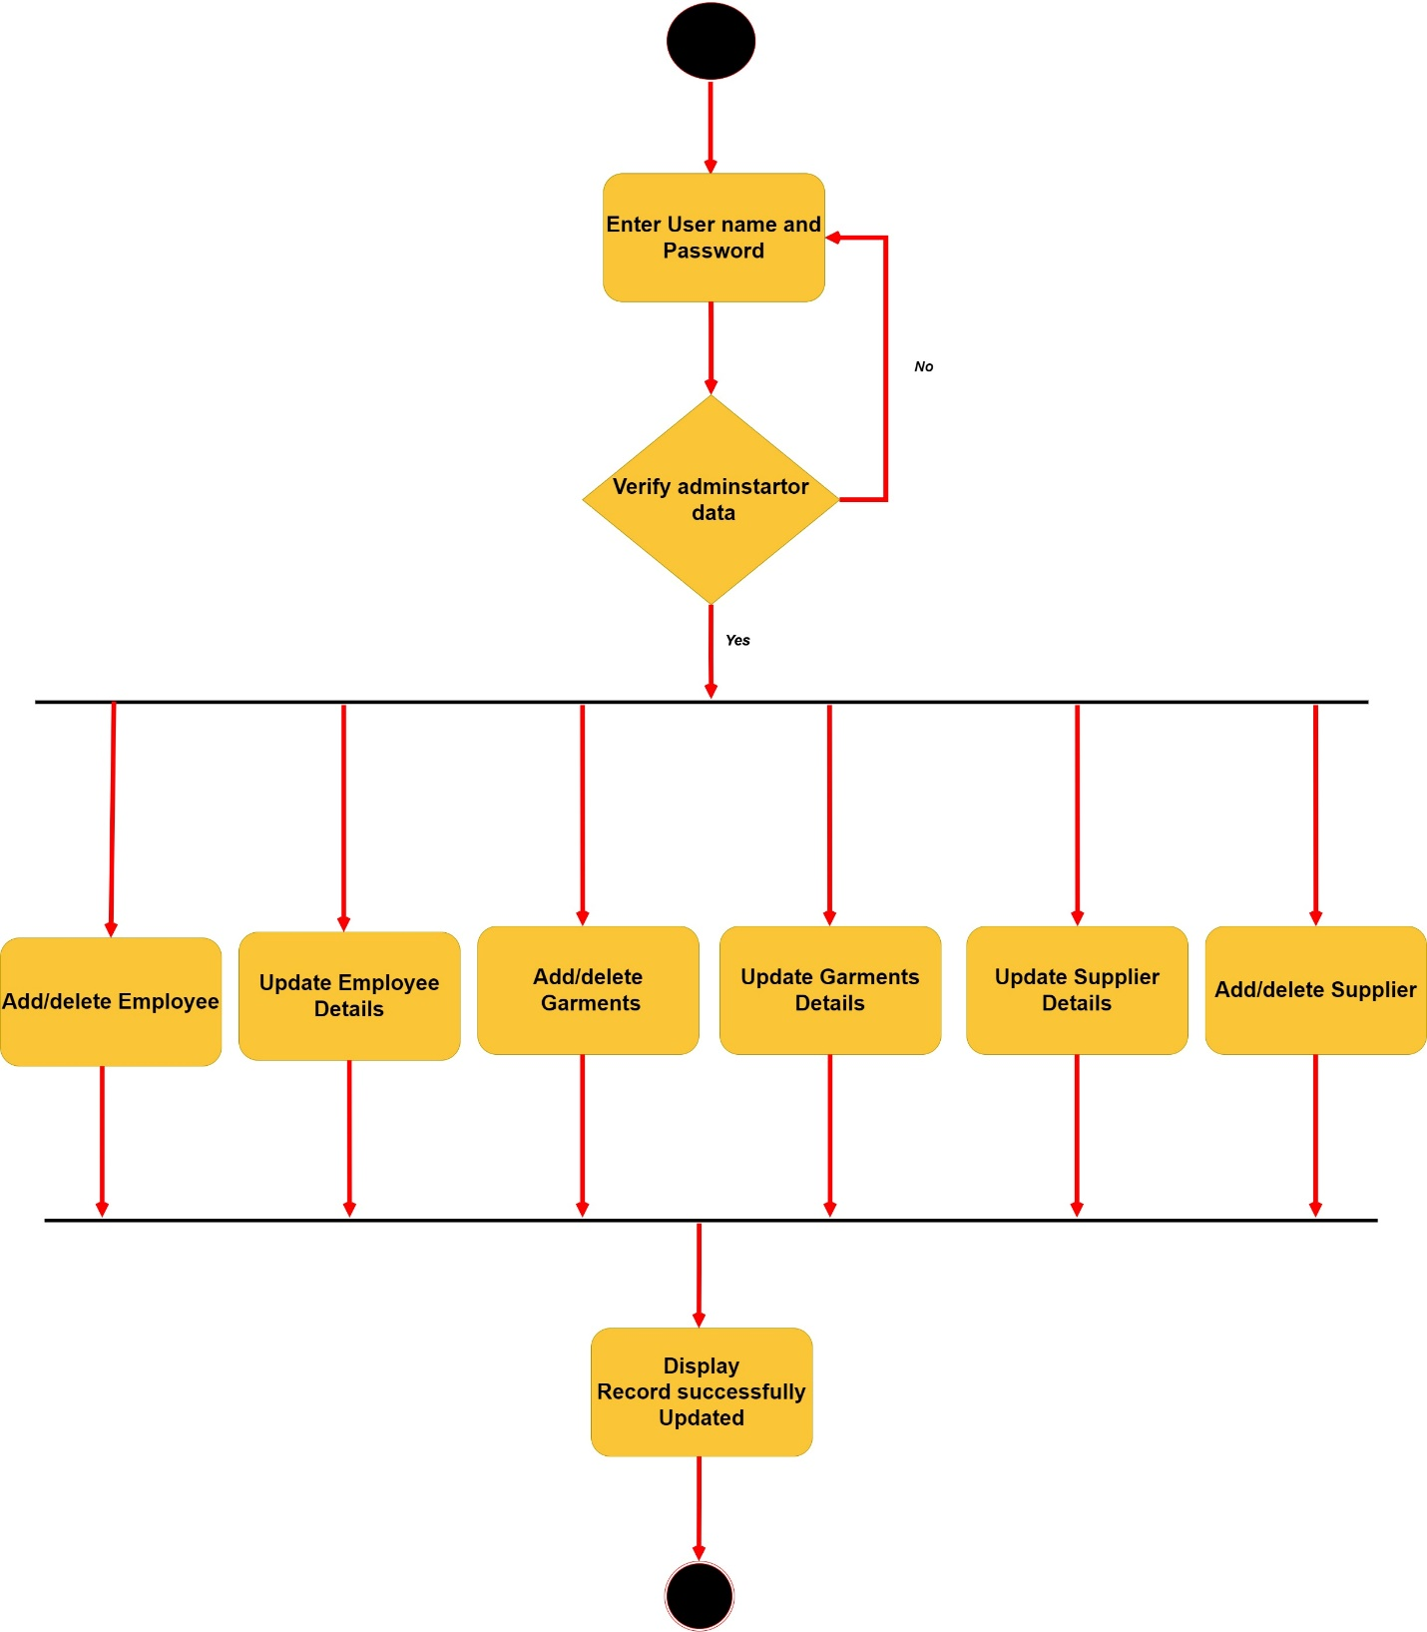

**OFFER Discount:**

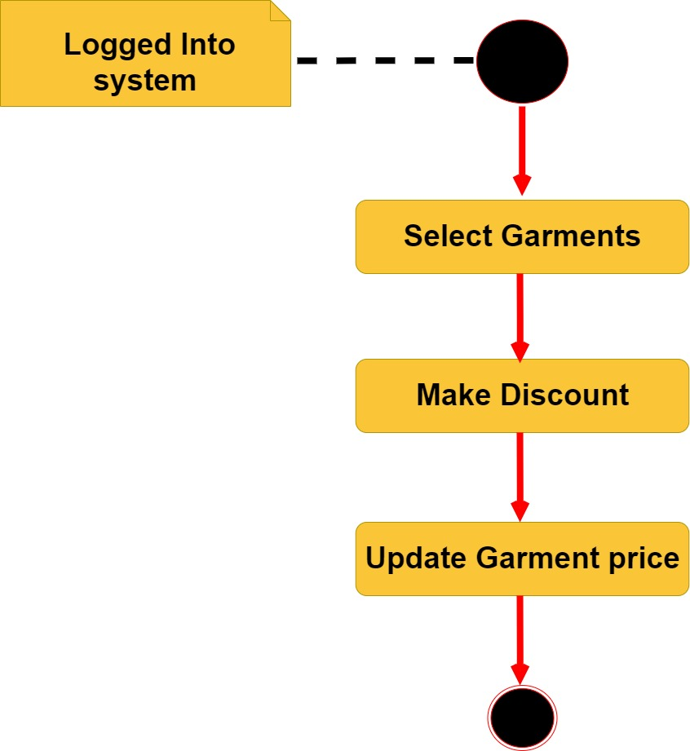

**Generate Reports:**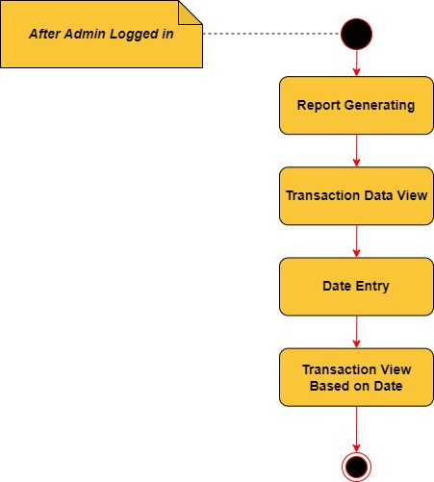

**Class Diagram :**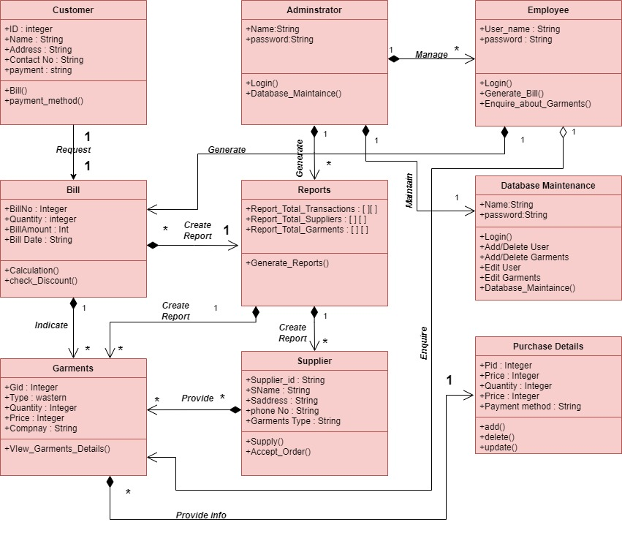

**Sequence Diagram:**

**Employee Customer:**

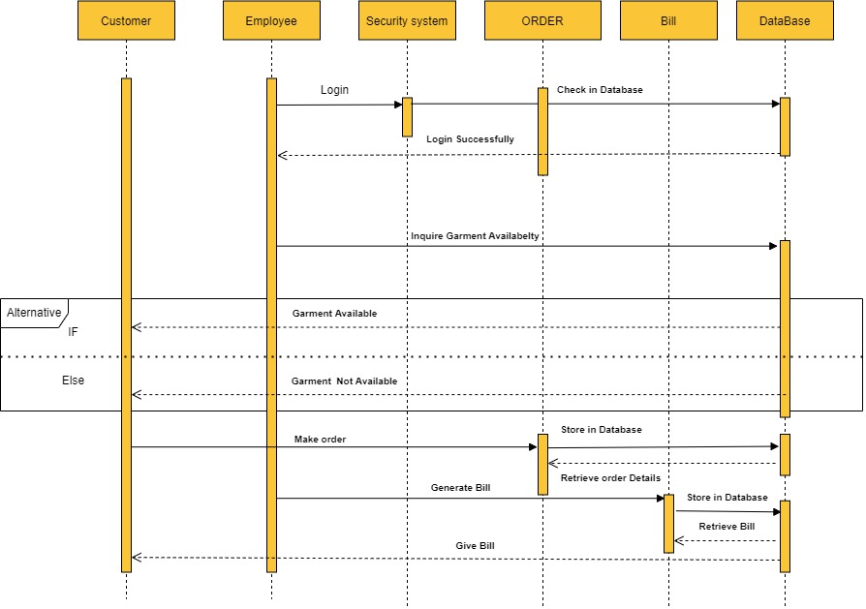

**Admin Supplier:**

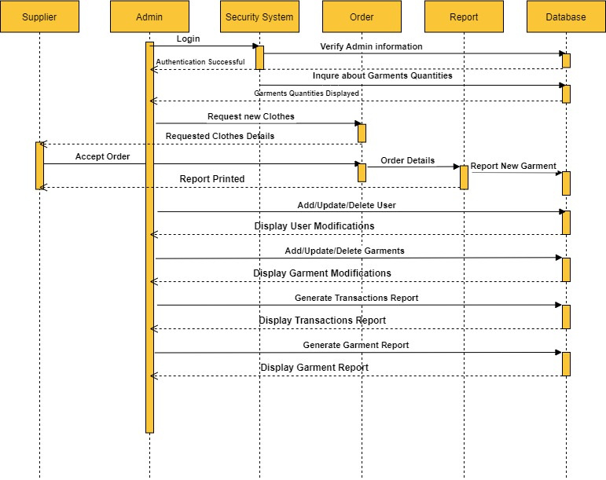

**State Diagram:**

**Customer State Diagram**

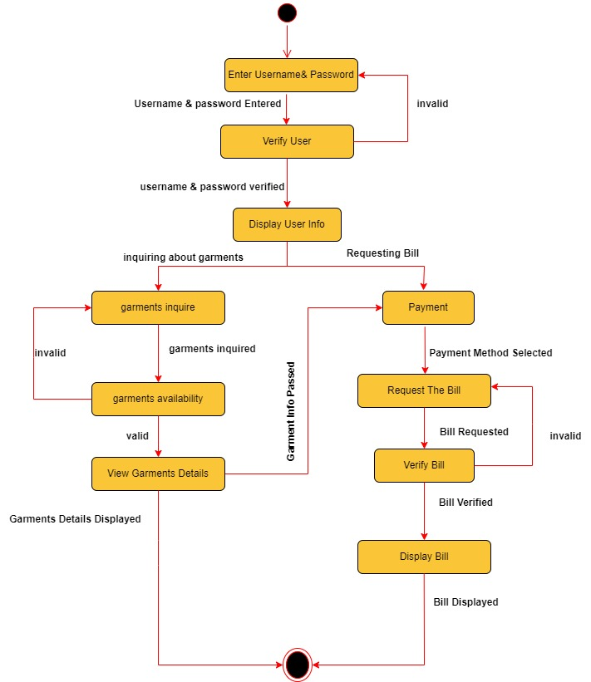

**Employee State Diagram**

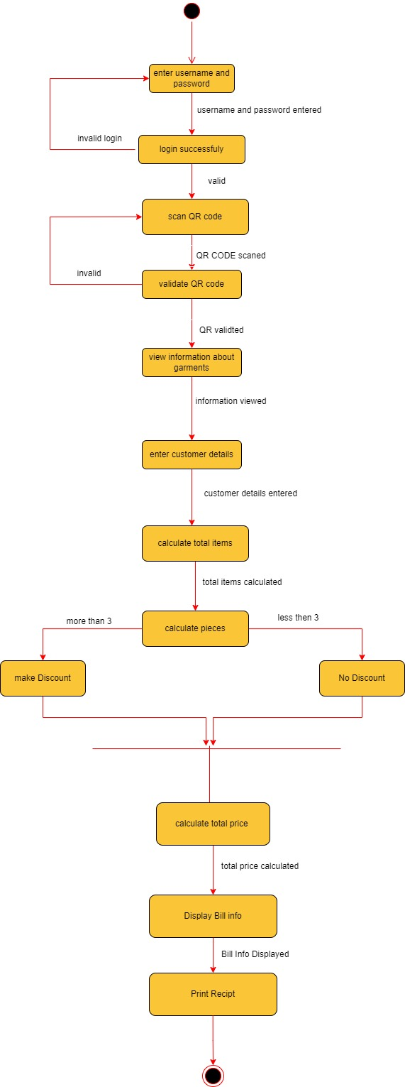

**Admin State Diagram**

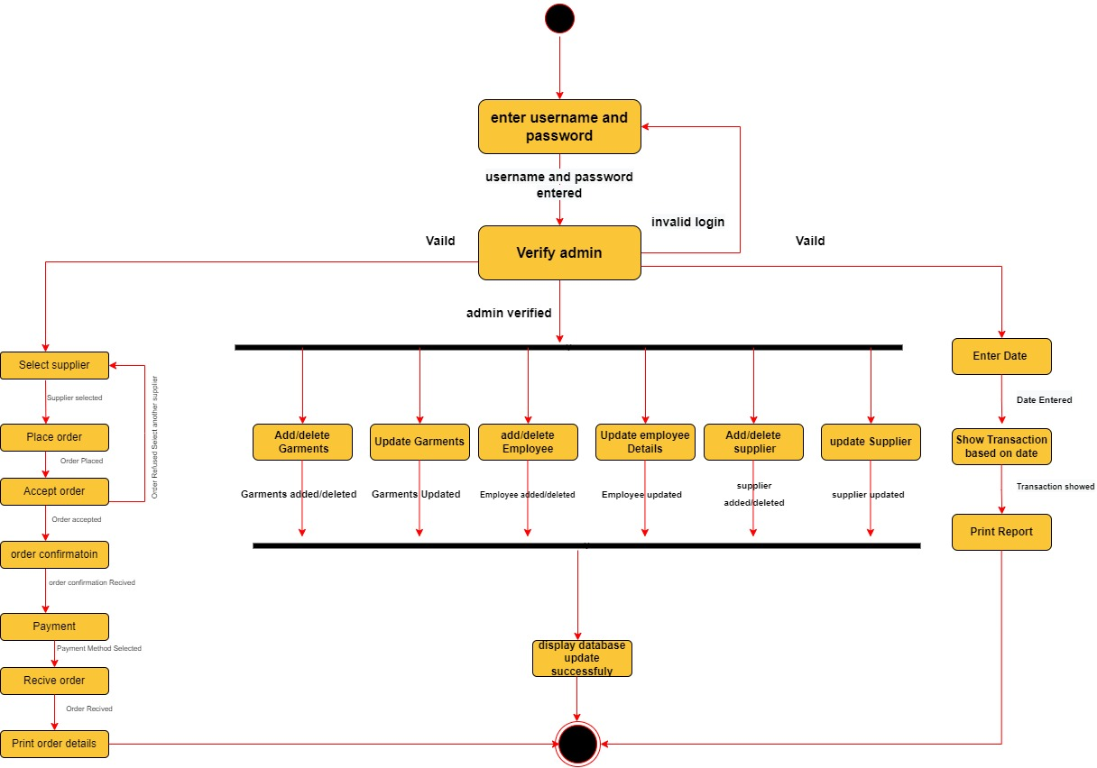

**Supplier State Diagram**

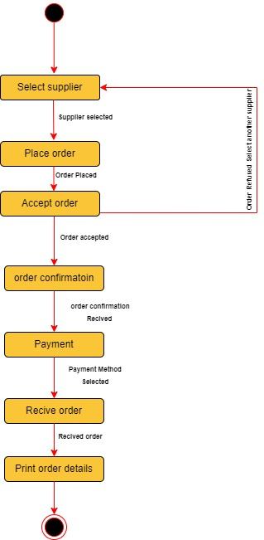

**Data Flow Diagram**

**Context Diagram (LEVEL 0)**

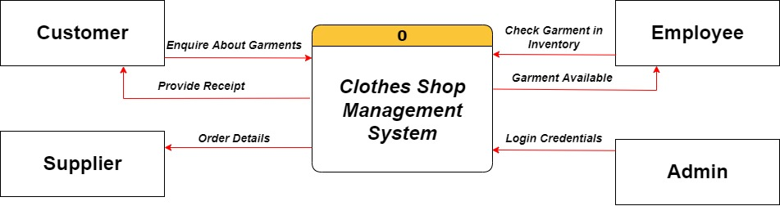

**DFD (Level 1)**

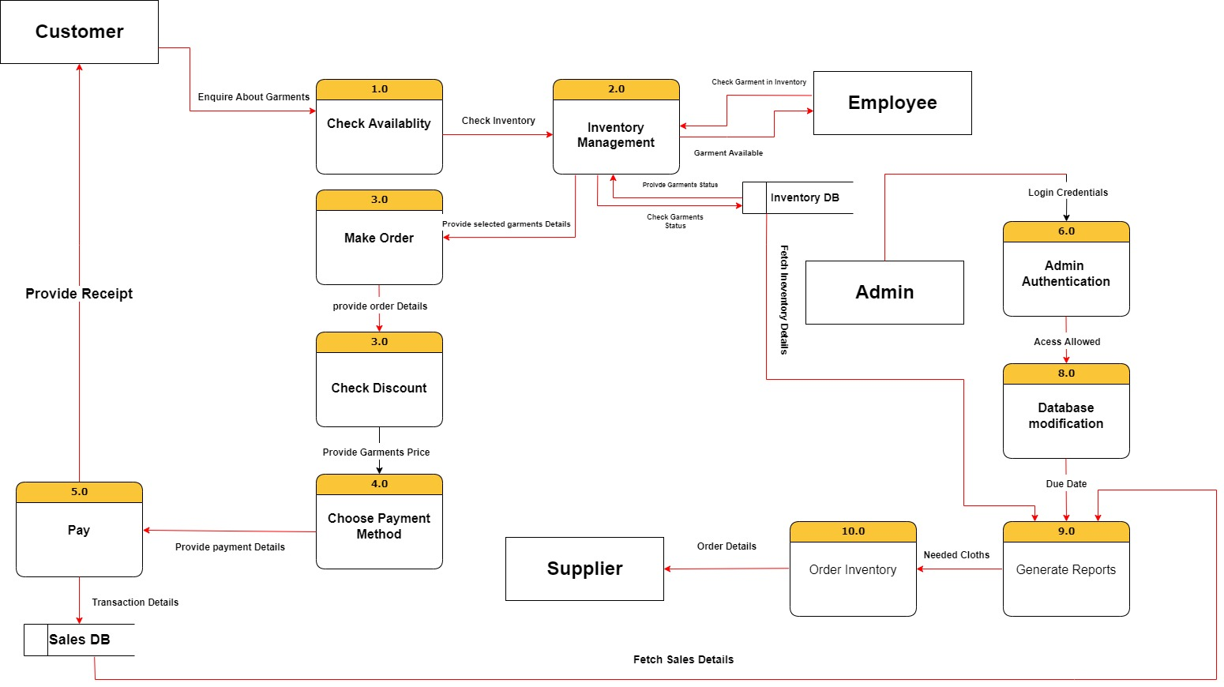

**Chapter 3**

**Login** 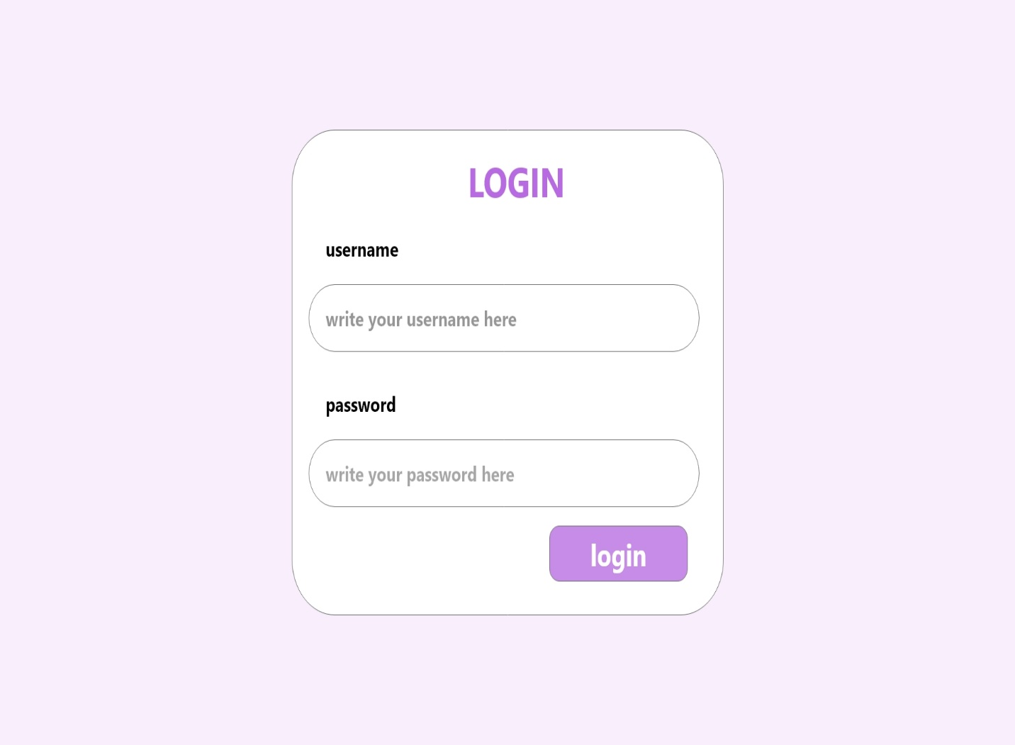

**Enquire Garments**

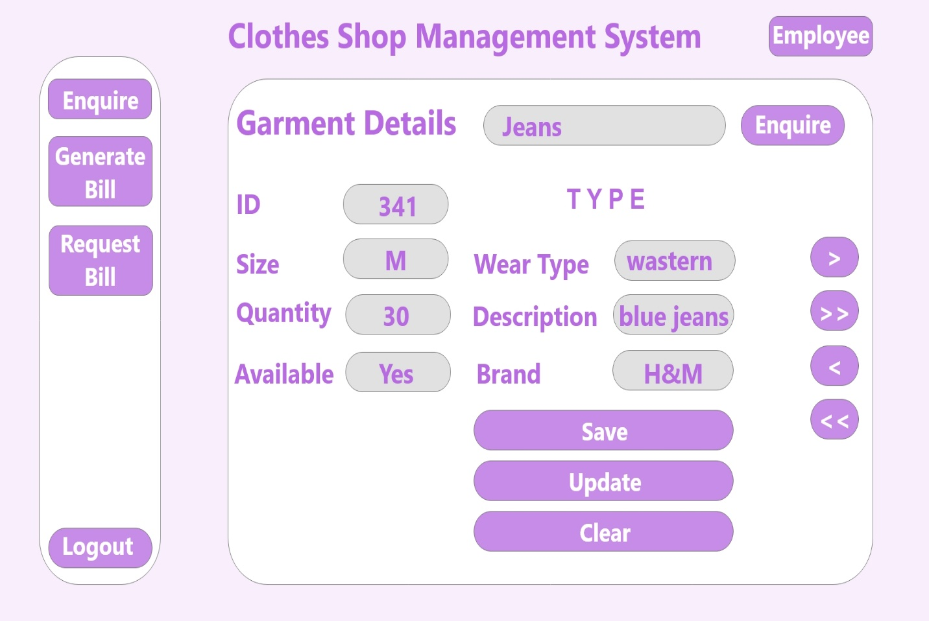

**Generate Bill**

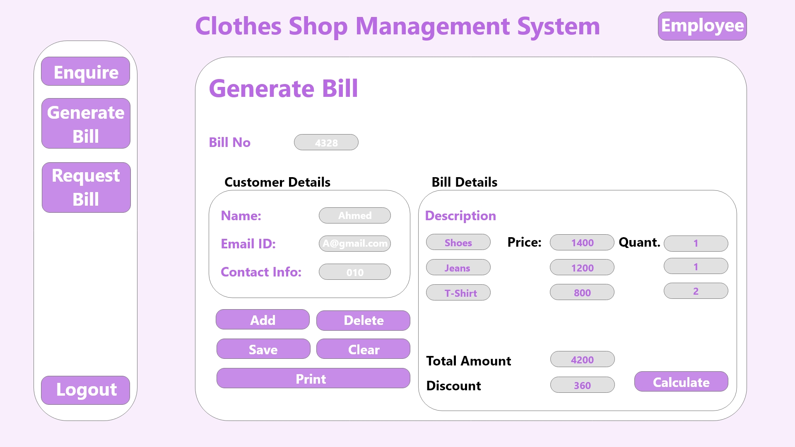

**Request Bill**

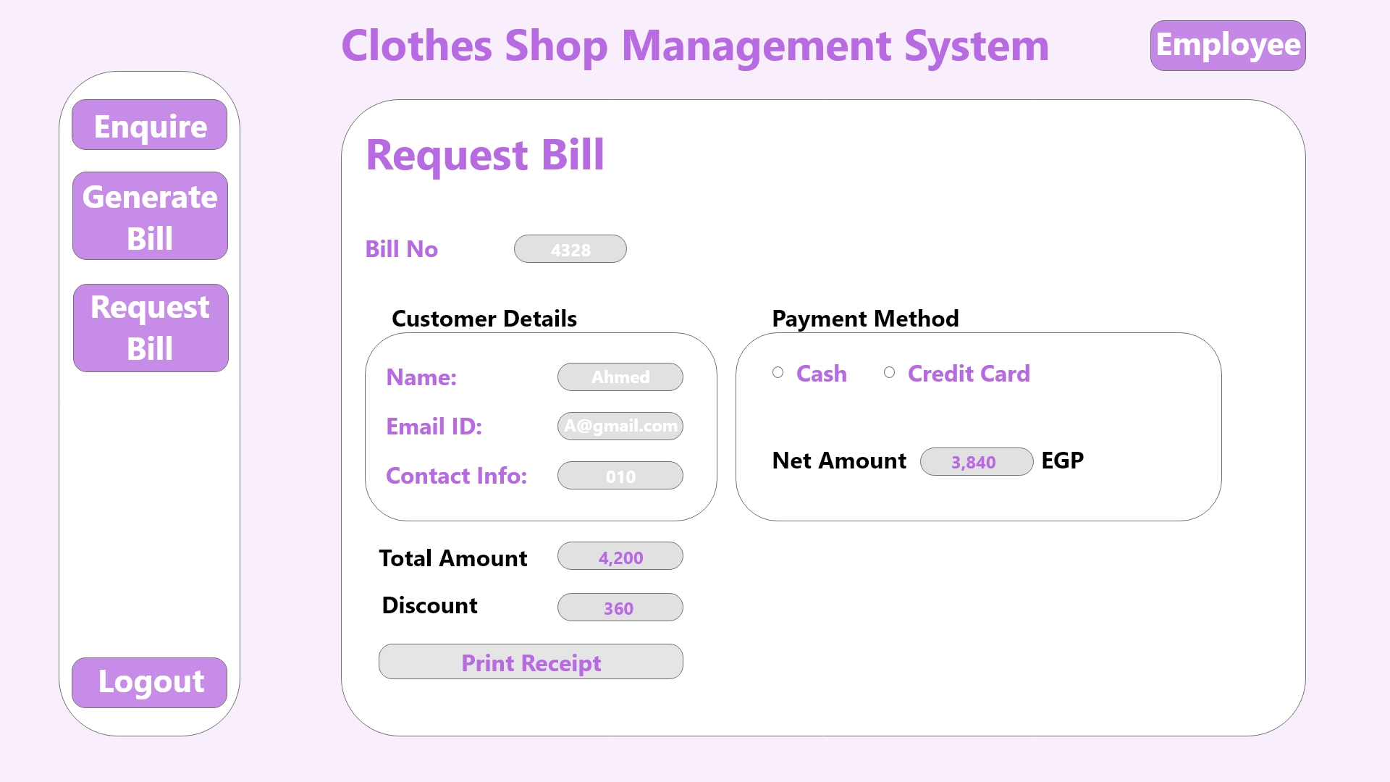

**Modify Garments**

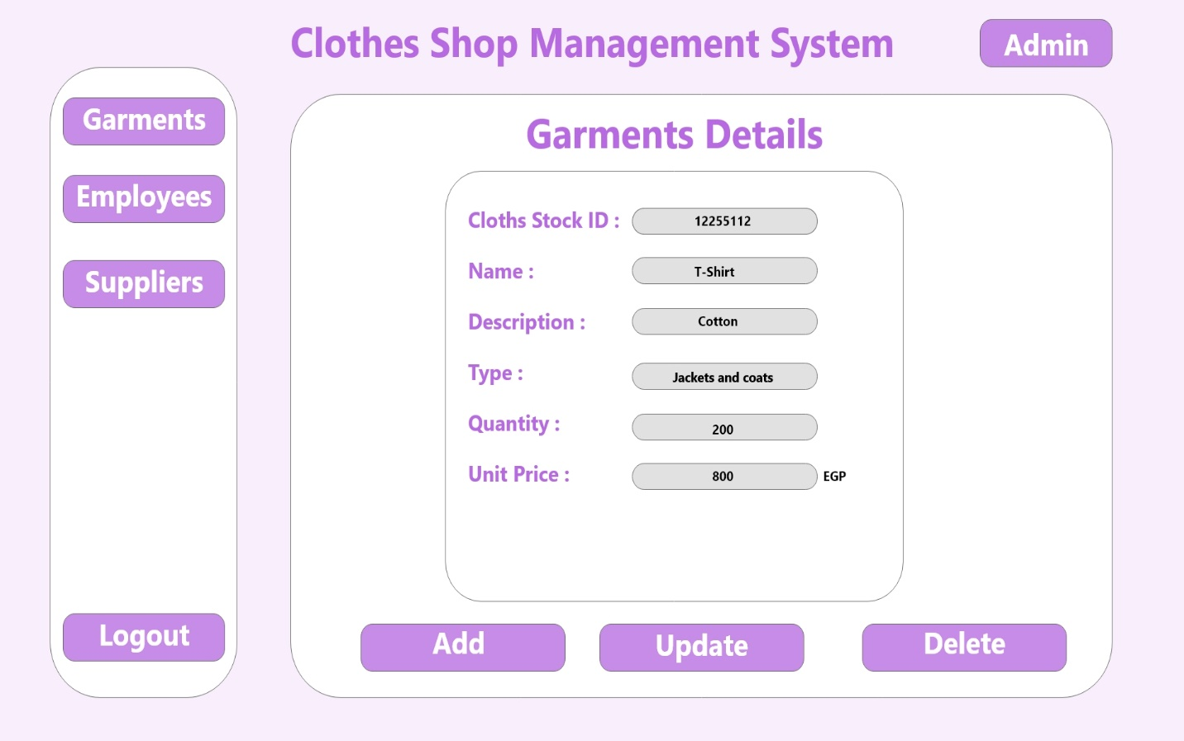

**Modify Employee Details**

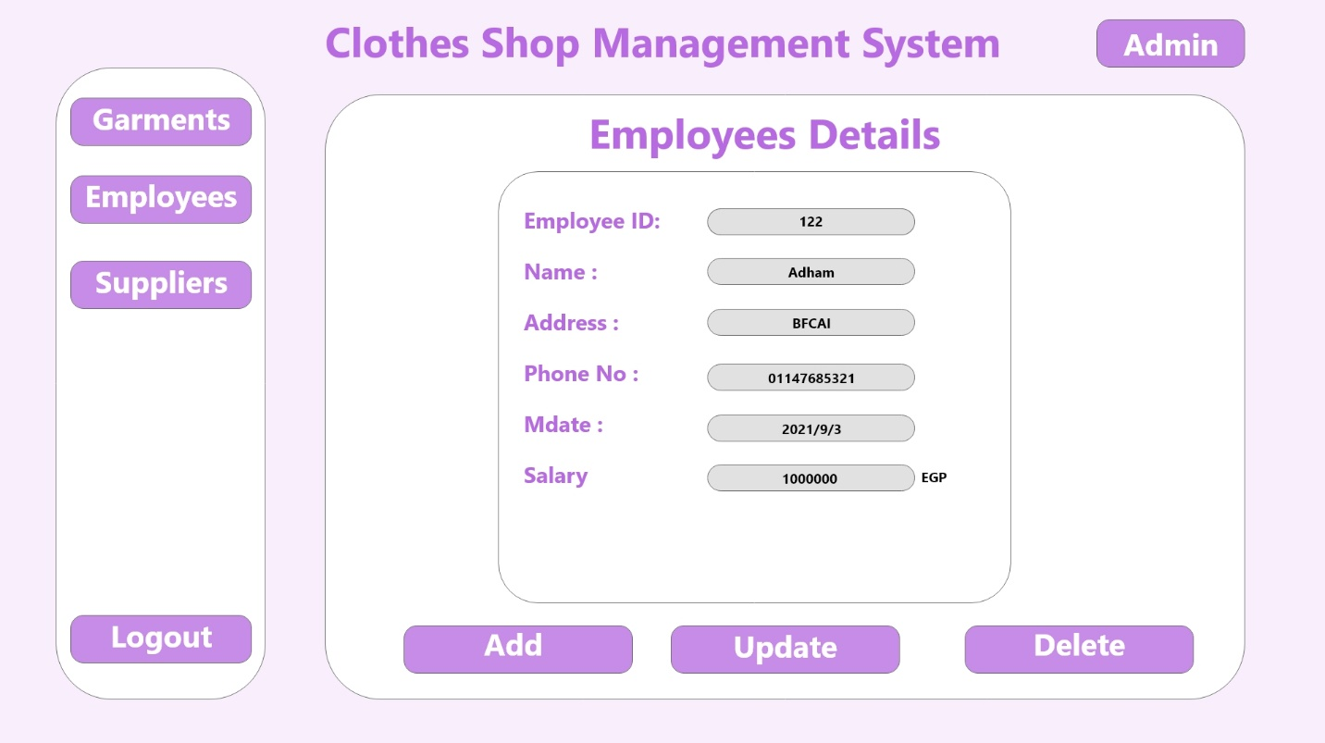

**Modify Supplier Details**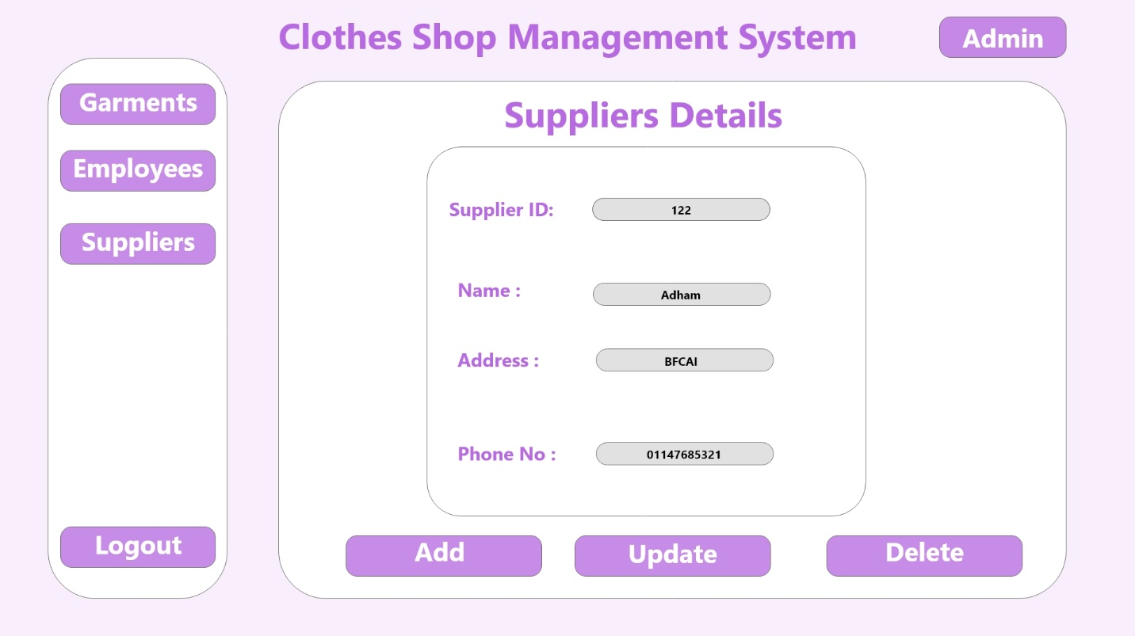

**Generate Garments Reports**

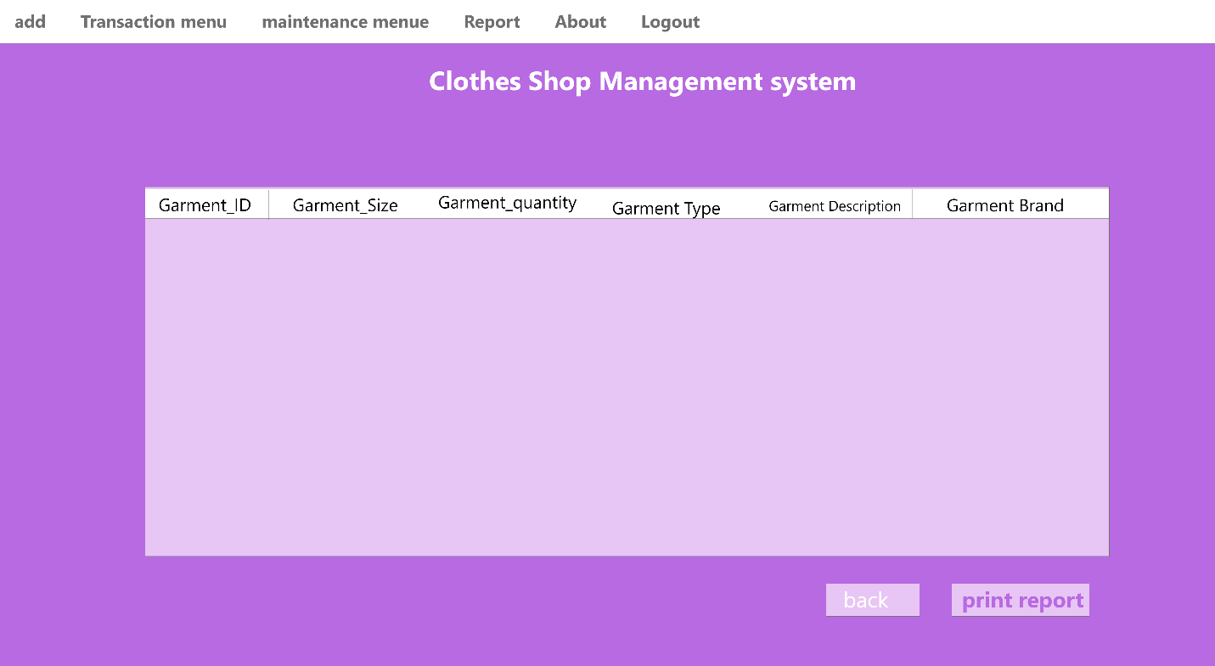

**Generate Transactions Reports**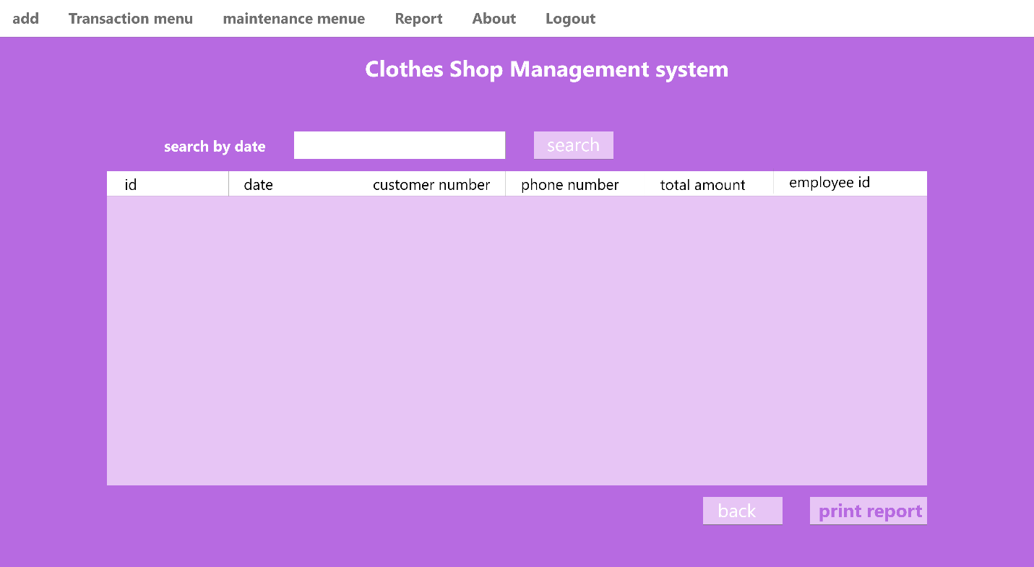

**Generate Supplier Reports**